Ideation Phase
Brainstorm & Idea Prioritization Template

Date | 27 February 2026
Team ID | LTVIP2026TMIDS66231
Project Name | IntelliSQL: Intelligent SQL Querying with LLMs using Gemini Pro
Maximum Marks | 4 marks

Brainstorming for “IntelliSQL: Intelligent SQL Querying with LLMs using Gemini Pro”:
Brainstorming for the project “IntelliSQL: Intelligent SQL Querying with LLMs using Gemini Pro” focuses on exploring how large language models (LLMs) can be used to translate natural language questions into accurate SQL queries. The main goal of this brainstorming session is to generate ideas on how IntelliSQL can assist students, developers, analysts, and businesses in querying databases without needing expertise in SQL syntax.
IntelliSQL can solve this problem by leveraging Gemini Pro’s advanced natural language understanding to interpret user queries and generate optimized SQL statements. The system will bridge the gap between non-technical users and relational databases by providing accurate, context-aware SQL generation along with query explanations and result summaries.
Step-1: Team Gathering, Collaboration and Select the Problem Statement:

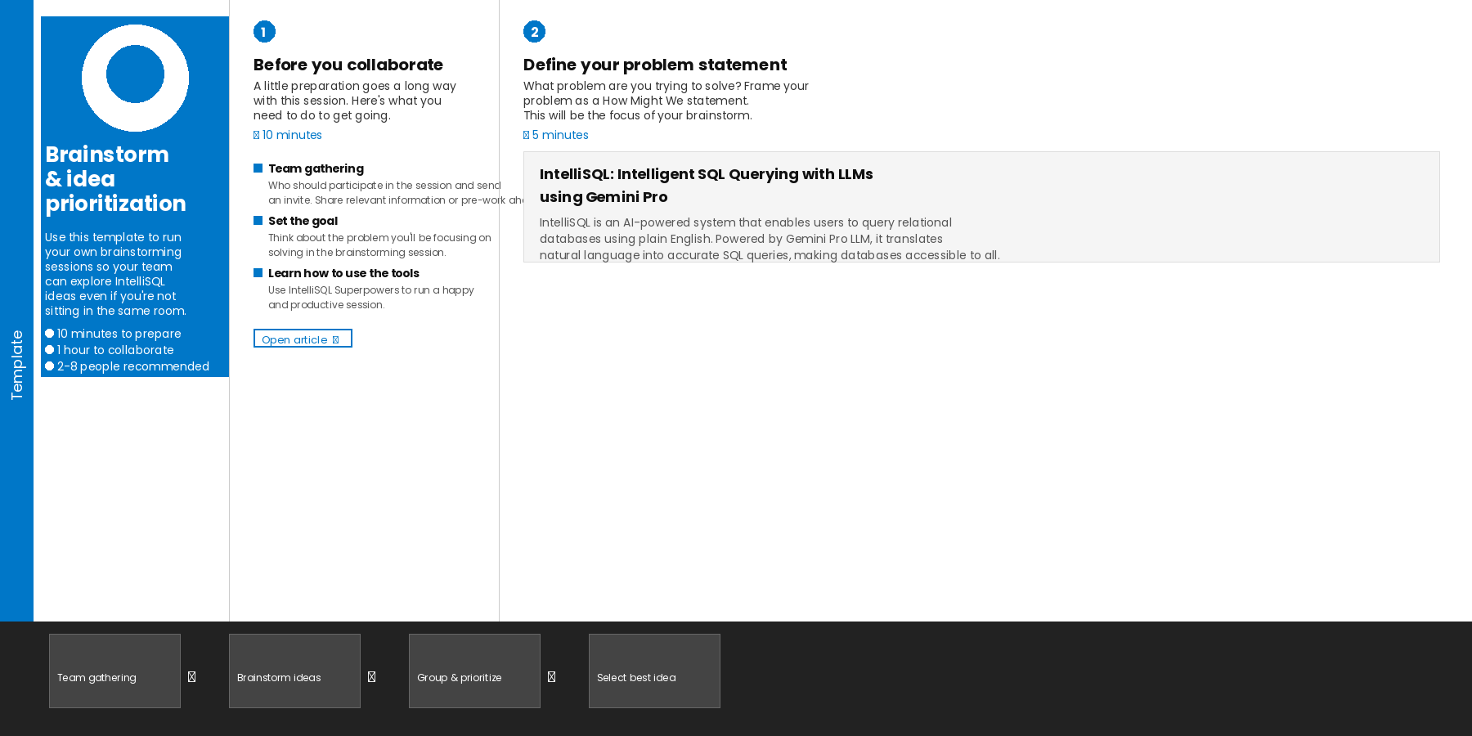

Step-2: Brainstorm, Idea Listing and grouping:

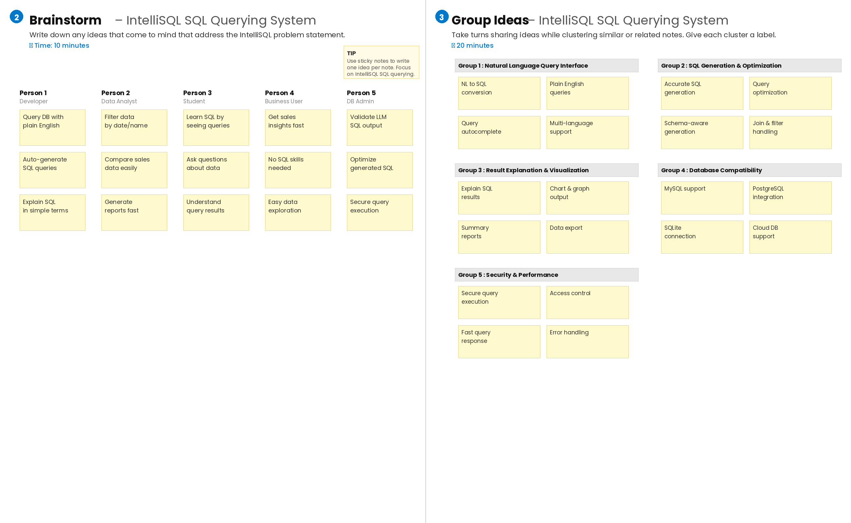
Step-3: Idea Prioritization

Idea prioritization for the IntelliSQL project focuses on selecting the most valuable and impactful features that improve SQL query generation and user experience.

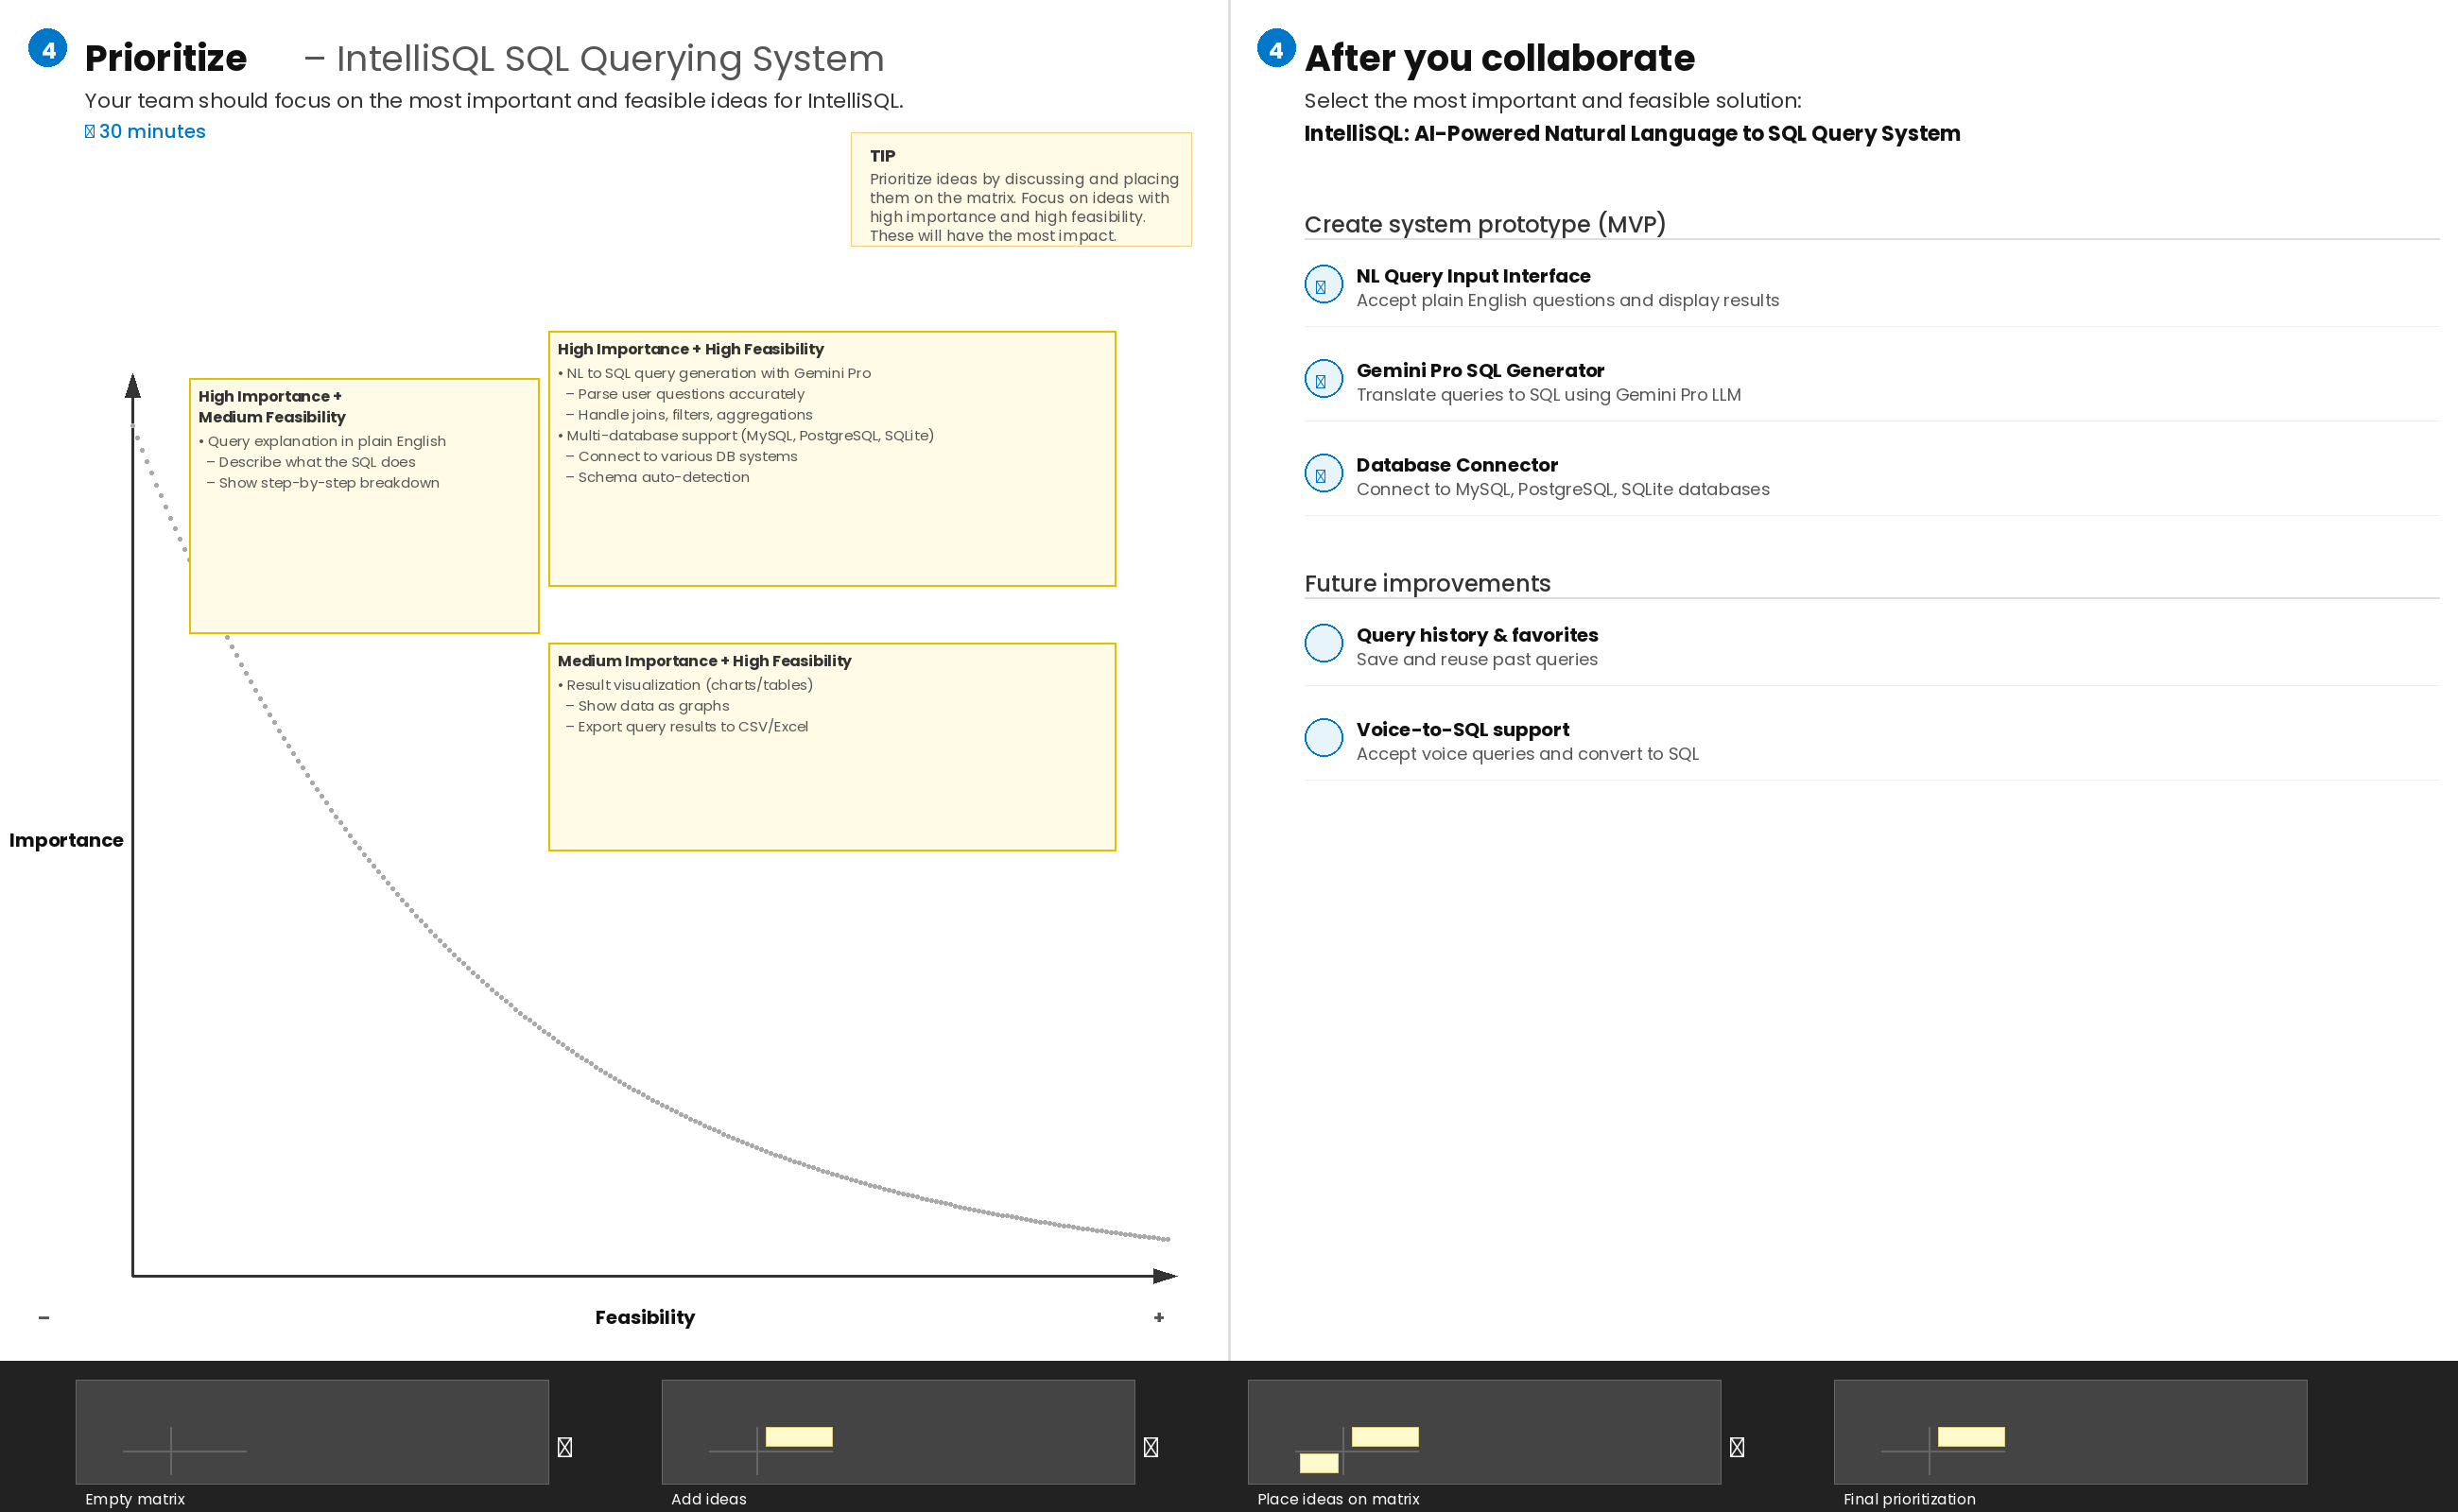
Here certainly we chose “Using Gemini Pro LLM to convert natural language queries into accurate SQL statements for seamless database interaction” as our most prioritized idea. Among all other ideas, this was the most important to us because the core purpose of IntelliSQL is to allow users to query databases using plain English without writing SQL manually. If Gemini Pro cannot accurately interpret natural language and produce correct SQL queries, the entire system becomes unreliable. Therefore, ensuring high-quality, accurate SQL generation is our top priority.

Then comes our second most important idea, which is “Integrating IntelliSQL with popular databases like MySQL, PostgreSQL, and SQLite to support multi-database environments.” This was taken as our second priority because broad database compatibility is essential for real-world adoption. By supporting multiple database systems, IntelliSQL becomes more versatile and useful for developers, analysts, and organizations working with different database platforms.

Then comes our next idea, which is “Providing additional features such as query explanation in plain English, query history, and result visualization for IntelliSQL users.” After achieving our main goal, we will expand the system to include these advanced features. This will make IntelliSQL more educational and user-friendly by helping users understand what each query does, review past queries, and visualize results through charts and tables. This will increase the overall value and effectiveness of the IntelliSQL project.

